Advanced Operating Systems | Midwestern State University
Memory Management | Placement Algorithms | Spring 2018

Samuel Weems

Information valid for both questions:
Assume that you have a system which memory has been allocated as follows
- First 11 kb is dedicated to the OS (all the following distributions are consecutive to the first one one)
- 10kb are taken
- 10 kb, Hole
- 20 kb, Taken
- 30 kb, Hole
- 10 kb Taken
- 5 kb, Hole
- 30 kb, Taken
- 20 kb, hole
- 10 kb, Taken
- 15 kb, Hole
- 20 kb, taken
- 20 kb, hole

Due: April 4, 2018, class time.

Question 1
[50 points]
Imagine that you have a system that uses first-fit as the memory placement algorithm. Memory is already distributed as indicated on the first page. Later on three (3) request will be received in the following order (20 kb, 10kb, 5 kb).
At what starting address will each of the new request will be allocated?
For b through d, the new job with a different color to the others

Show this as follows:
- Horizontal memory diagram for original distribution (before requests)
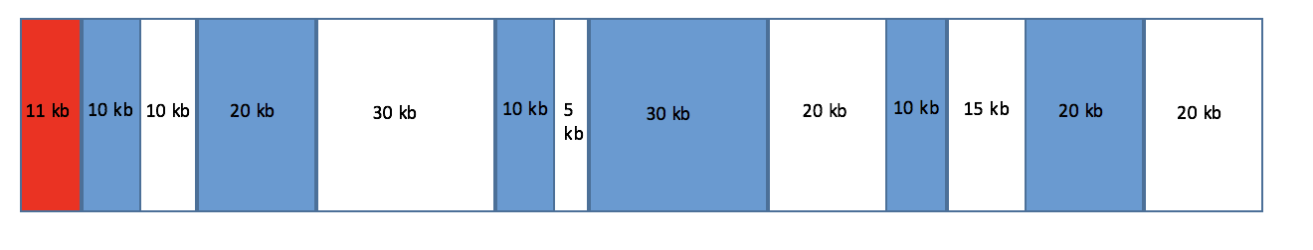

- Horizontal memory diagram after first request has been served
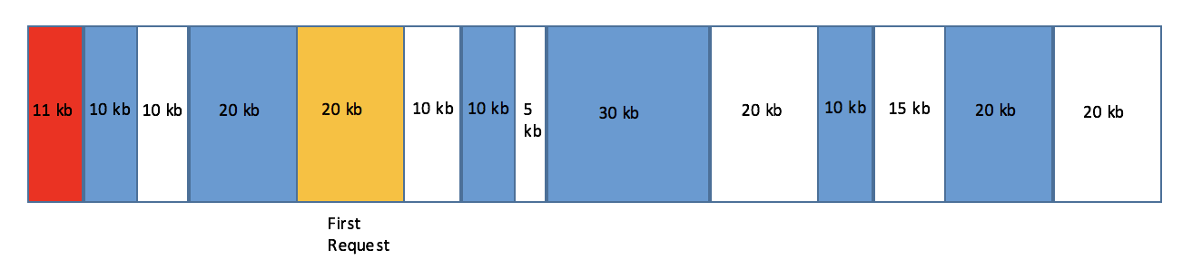
- Horizontal memory diagram after second request has been served
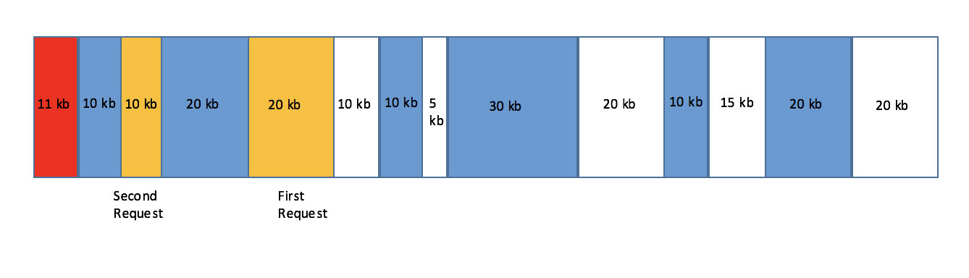
- Horizontal memory diagram after third request has been served

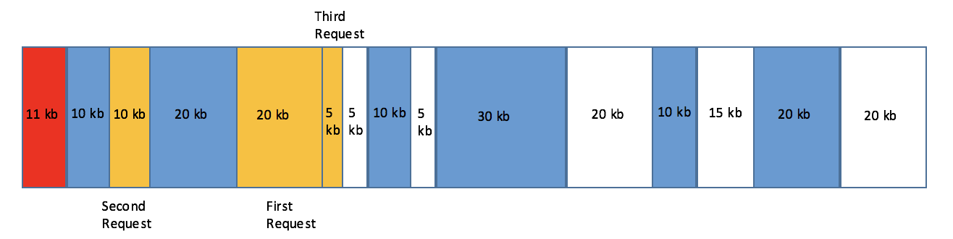
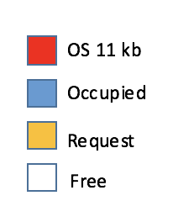
Question 2
[50 points]
Imagine that you have a system that uses best-fit as the memory placement algorithm. Memory is already distributed as indicated on the first page. Later on three (3) request will be received in the following order (20 kb, 10kb, 5 kb).
At what starting address will each of the new request will be allocated?
For b through d, the new job with a different color to the others

Show this as follows:
- Horizontal memory diagram for original distribution (before requests) (Yes, it is the same as the previous one, this one will not receive points, but points will be subtracted if not given)

- Horizontal memory diagram after first request has been served
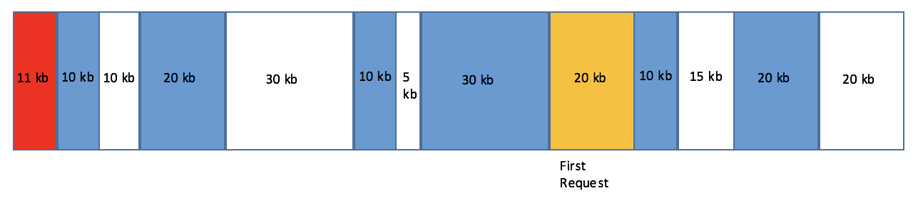
- Horizontal memory diagram after second request has been served

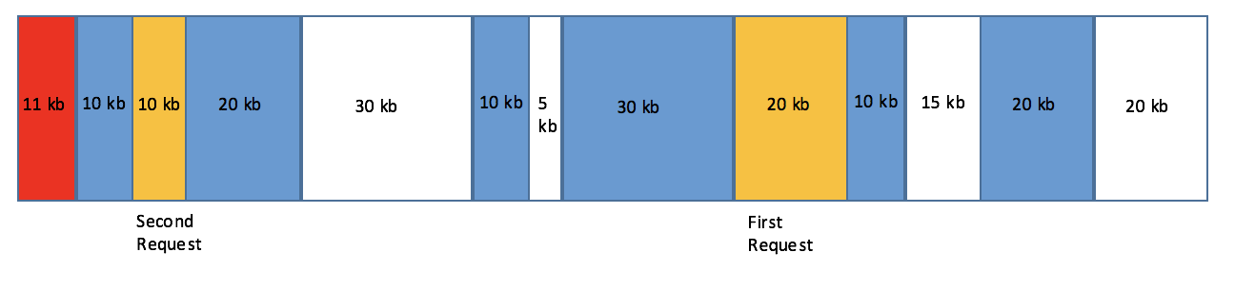

- Horizontal memory diagram after third request has been served
